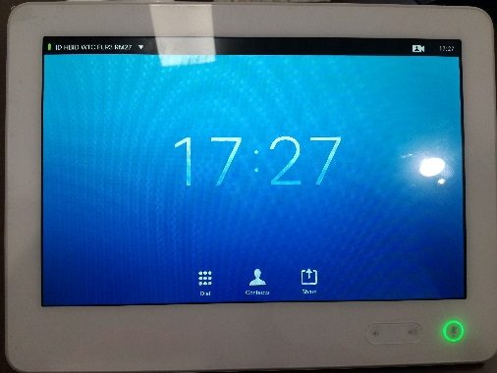

8

7

6

5

4

3

2

1

Introduction to Video Conferencing

1. Tap the upper left corner to activate /deactivate the Do Not Disturb feature, to activate /deactivate the Standby feature, and to access the Settings.
2. Tap Dial to invoke the dial pad.
3. Tap Contacts to invoke the list of contacts including Favorites, Directory and Recents.
4. Tap Share to start sharing content and to conduct presentations.
5. Press and hold the left side of the Volume button to decrease the loudspeaker volume and the right side to increase the volume.
6. Press the Microphone button to mute / unmute microphone.
7. Tap Camera to activate selfview and camera settings.
8. Time of day is indicated in the upper right corner.





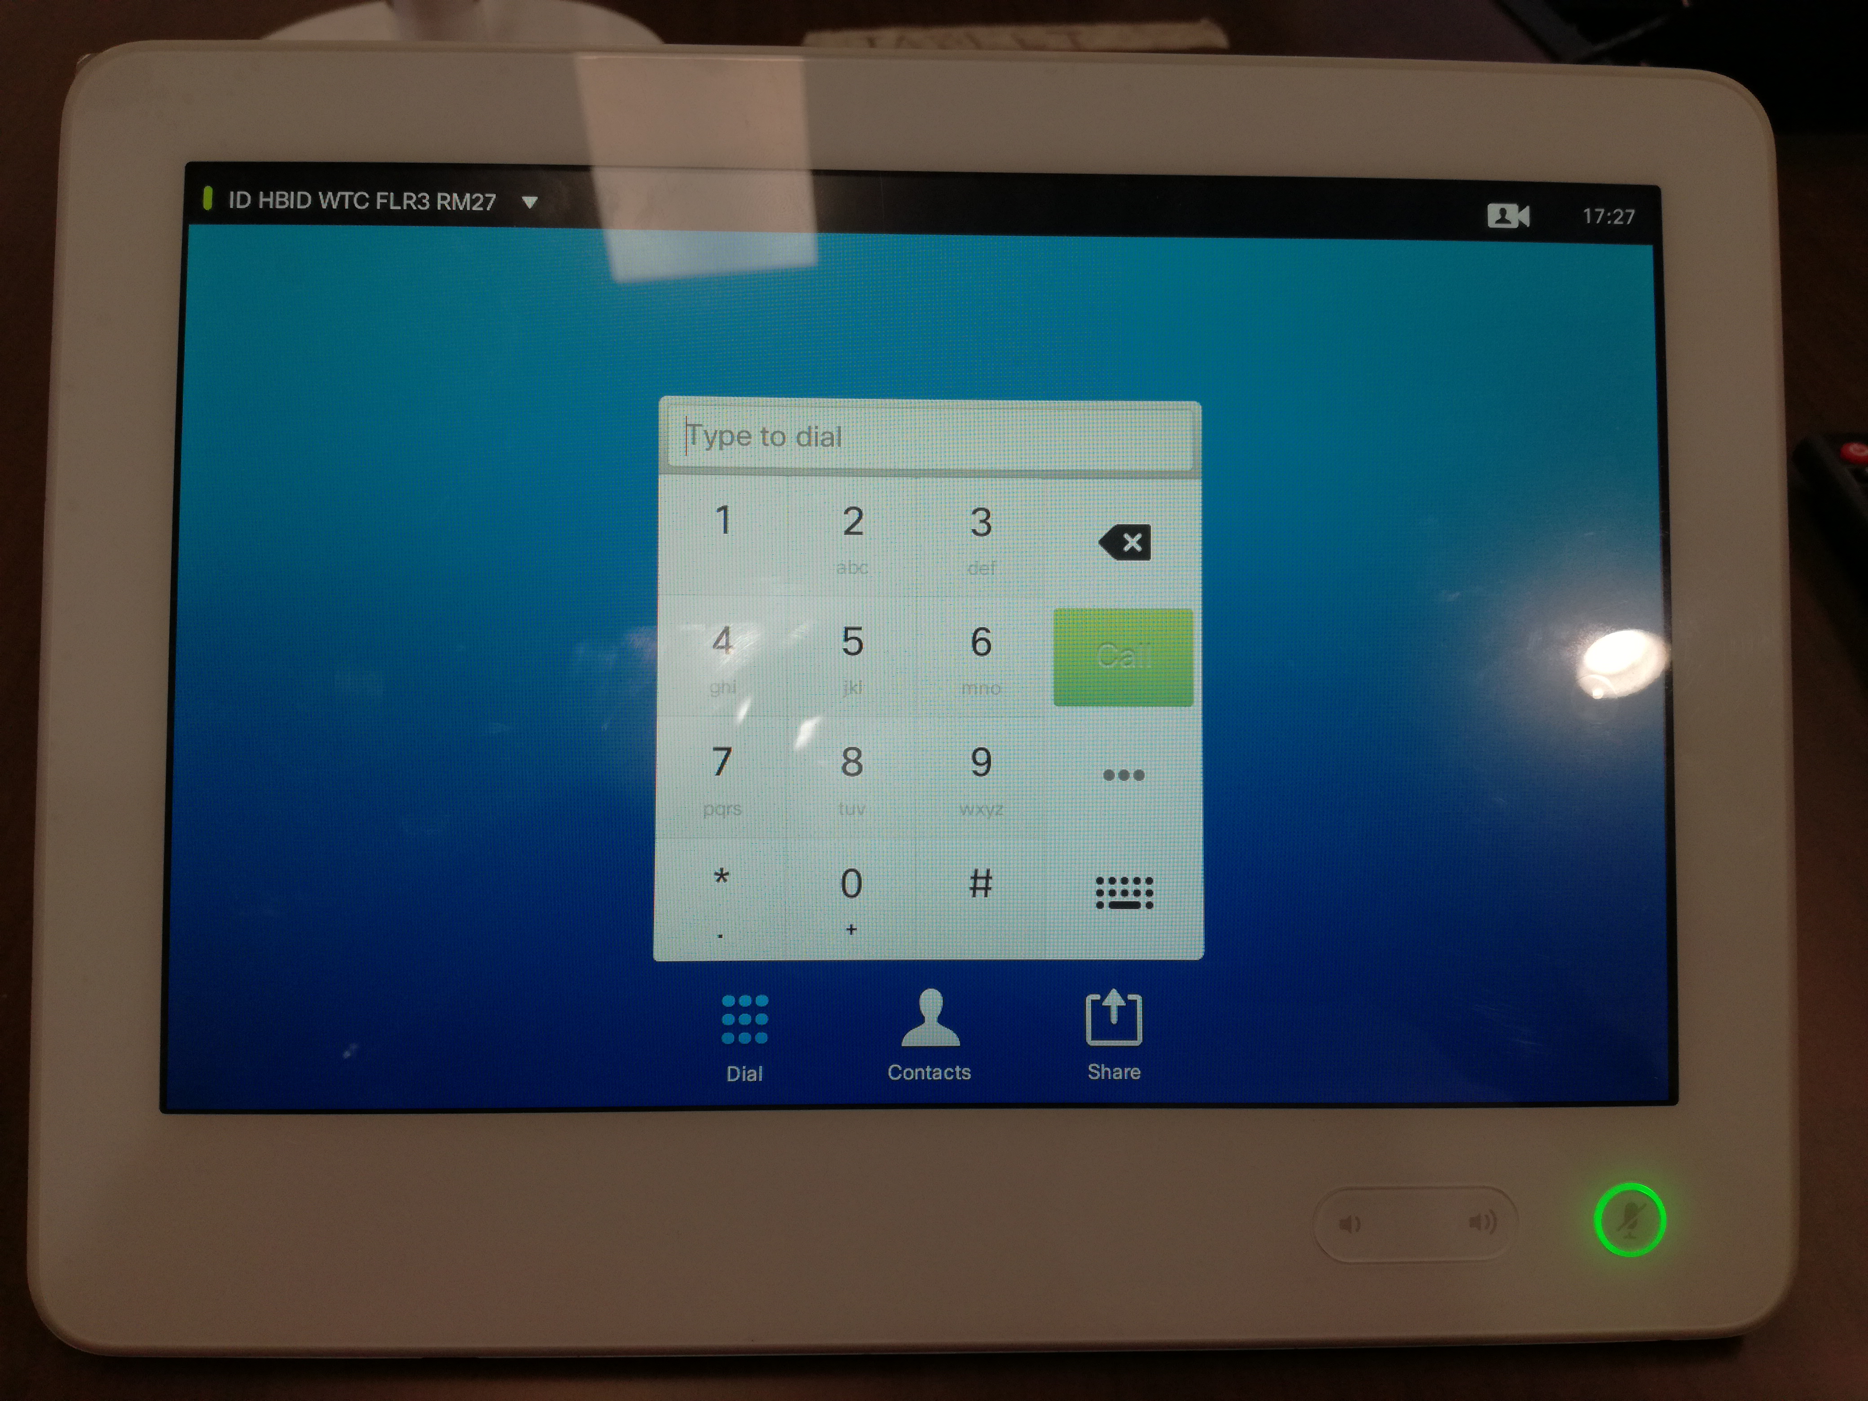

1. Place Call Using Name
2. Tap Dial, as outlined, to invoke the numerical dialpad.
3. Tap Keyboard, as outlined to invoke the virtual keyboard.
4. Key in the name. Matches will appear as you type.
5. There is an extended numerical mode available, which also contains special characters. To toggle between the alphanumerical mode and the extended numerical mode tap the key in the lower left corner of the keyboard, as outlined.
6. When you are ready to place the call, tap the green Call button.





A

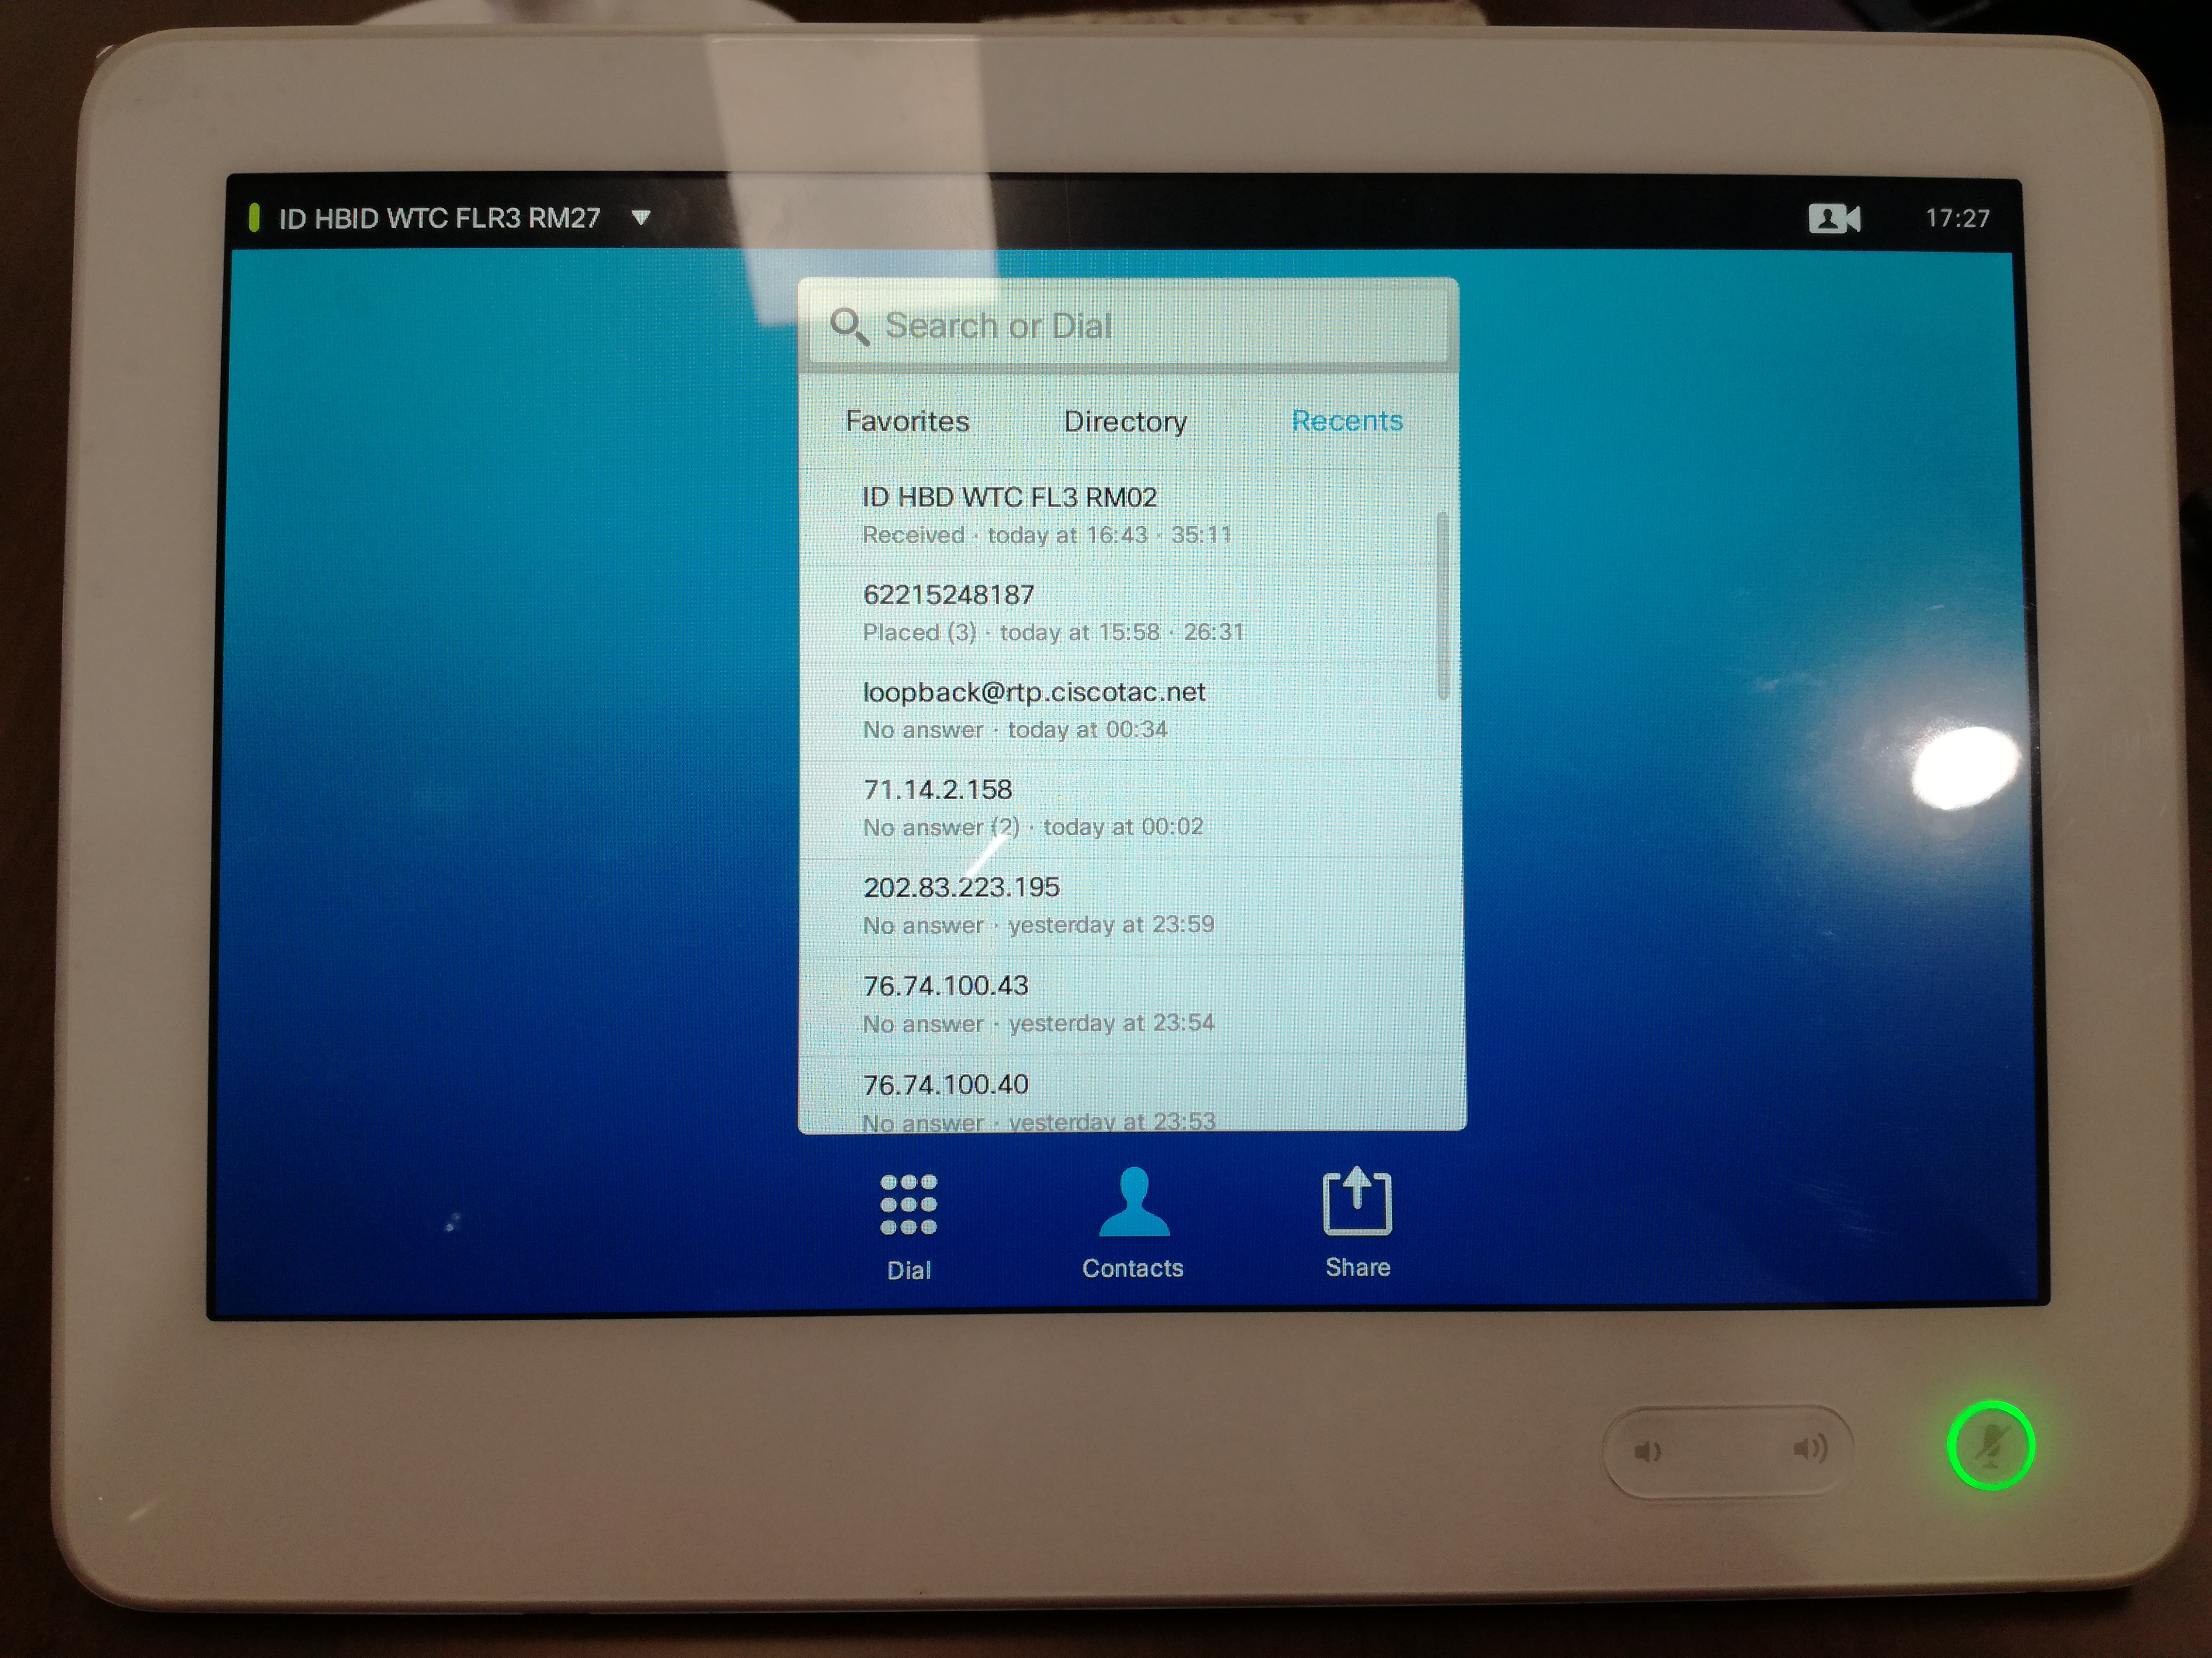

1. Place Call From Contact List
2. Tap Contacts, as outlined.
3. To search for someone in a specific list (Favorites,Directory or Recents), tap that list (a) and then scroll down (b) to locate the entry.
4. Alternatively, tap the Search or Dial field, as outlined. This will invoke the virtual keyboard.
5. Key in the name, number, or IP address. Matches will appear as you type.
6. There is an extended numerical mode available, which also contains special characters. To toggle between the alphanumerical mode and the extended numerical mode tap the key in the lower left corner of the keyboard, as outlined.
7. When you are ready to place the call, tap the green Call button.





B

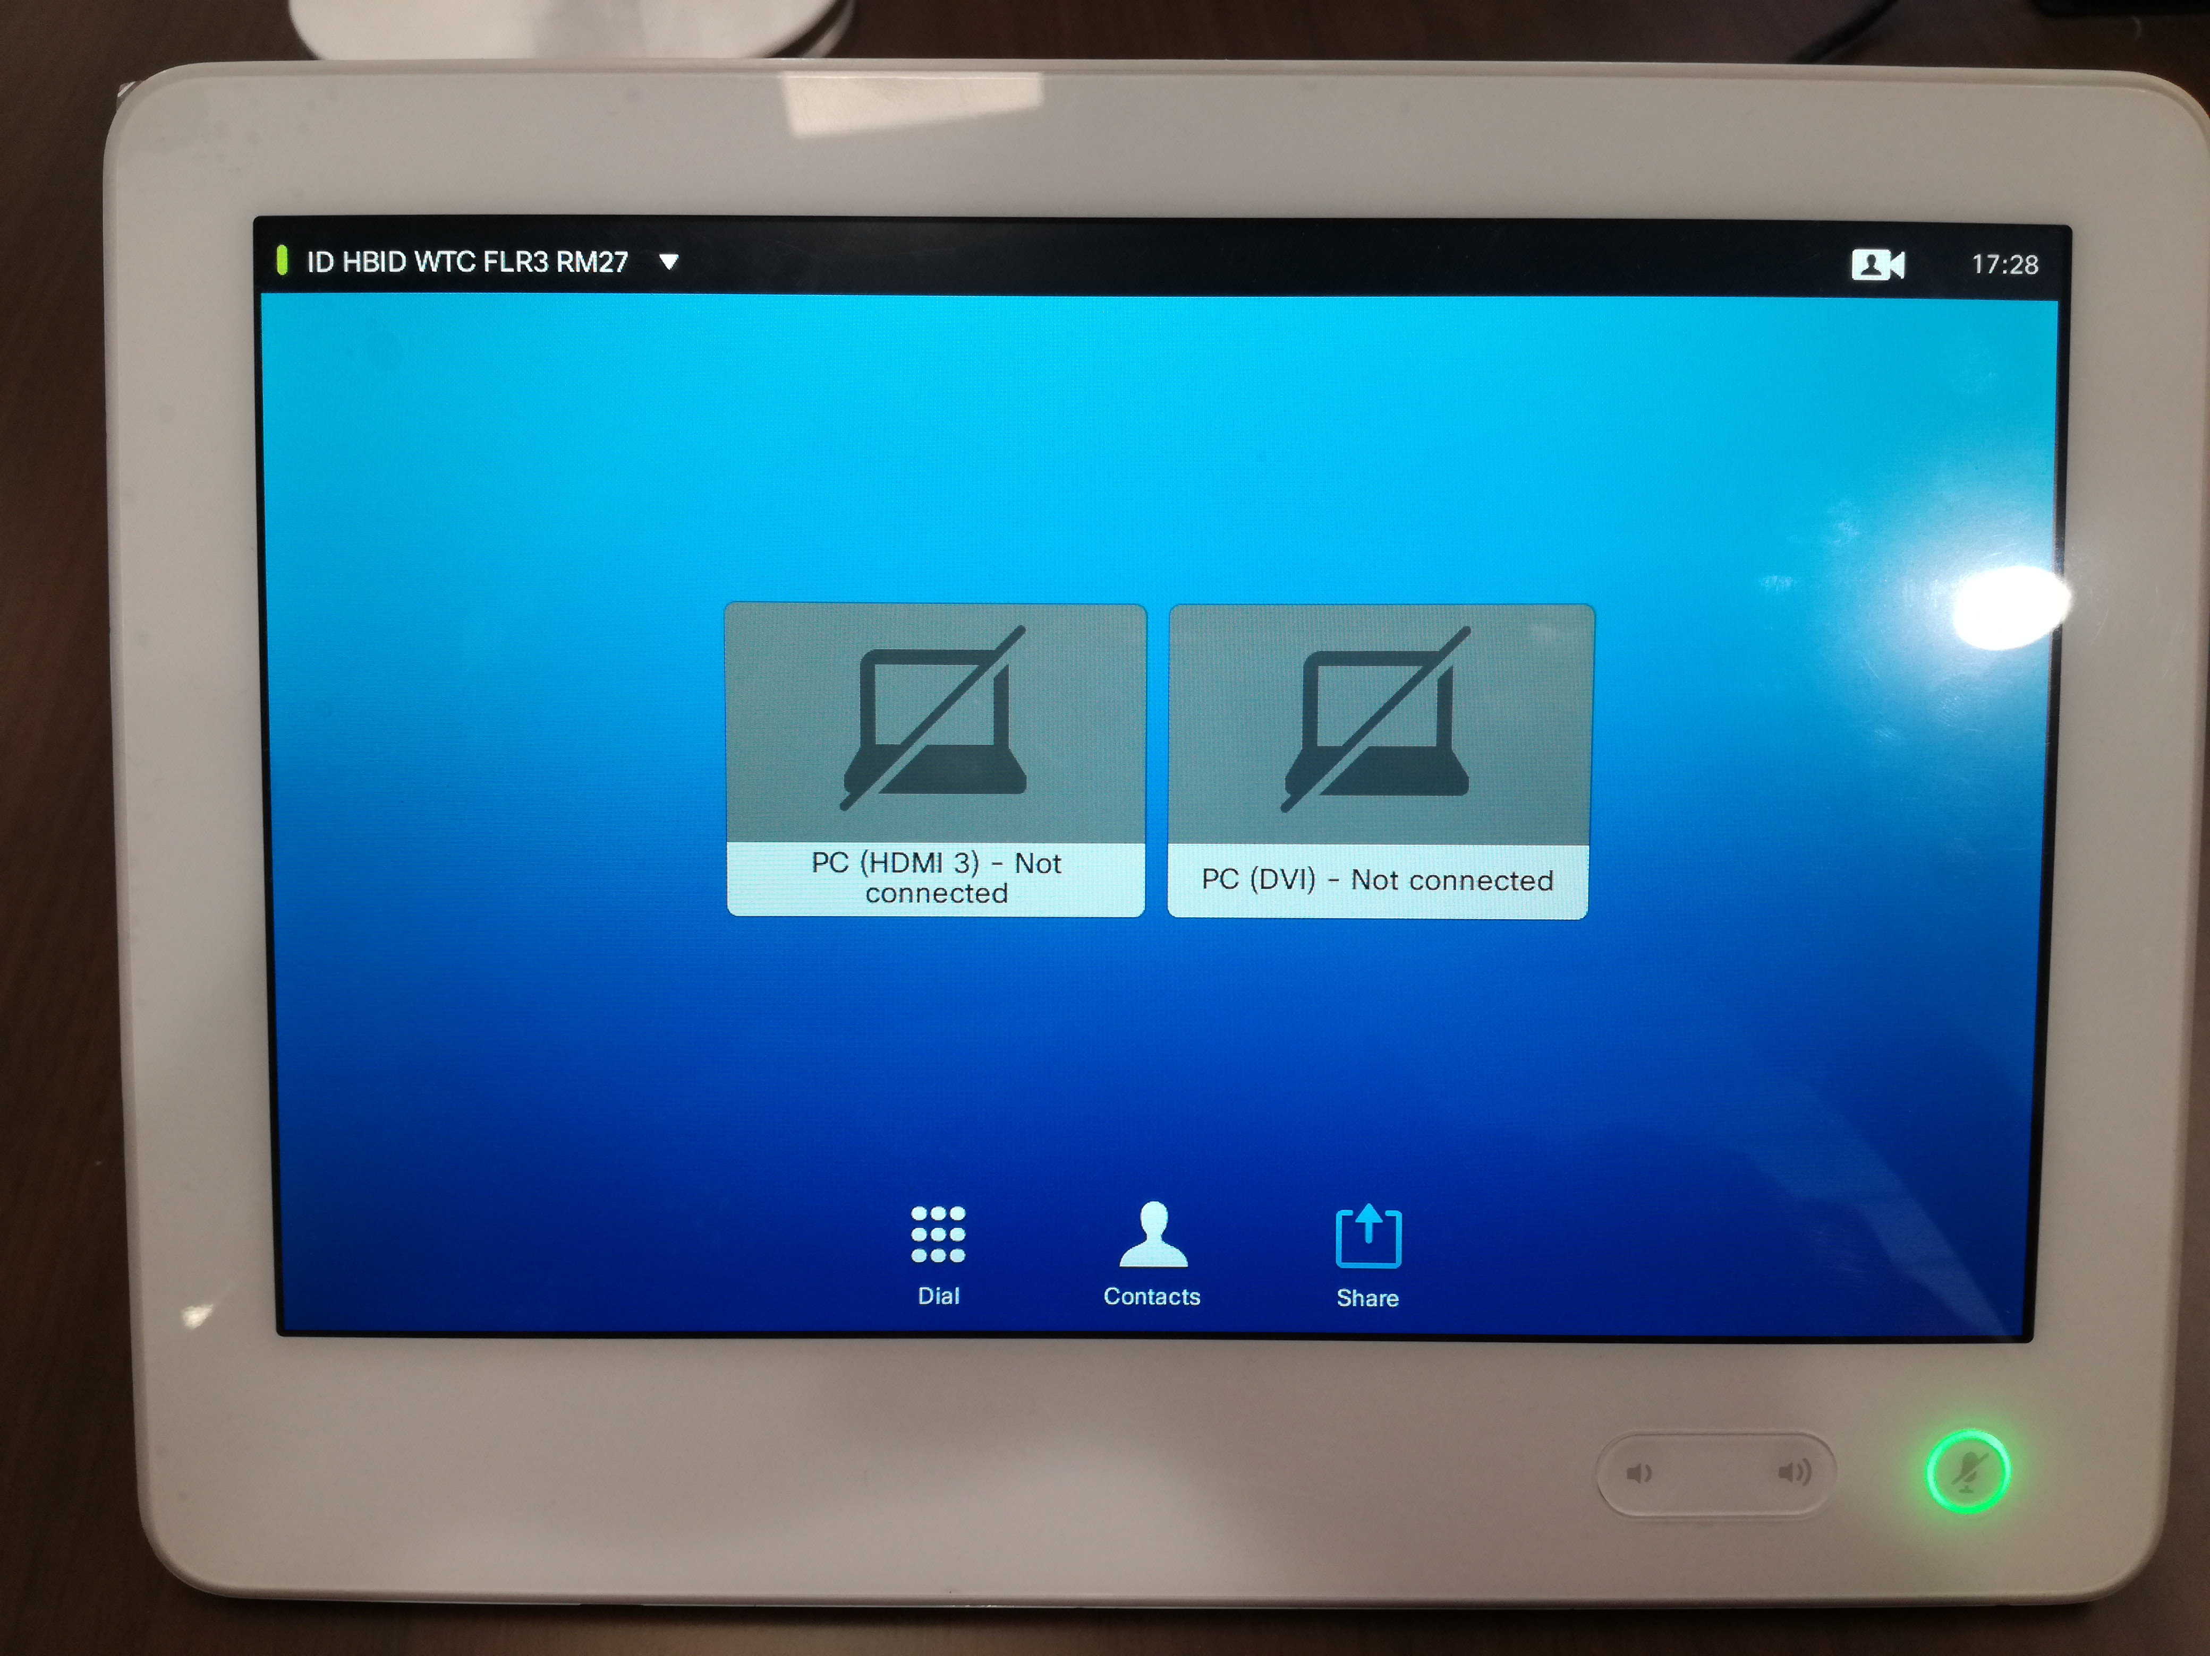

1. Start and Stop Presentation
2. Tap Share to start sharing content and to conduct presentations.
3. Tap Present (a), then scroll horizontally (b) to locate the presentation source, if needed. Once located tap the required source.
4. To stop the Presentation, tap Stop Presenting (a). The contact card (not shown) may be invoked even here, as outlined (b).





C

To Start Presentation/Sharing Content During Video Conference

1. Please use Input No.1 (HDMI Cable) to start presentation and content sharing during video conference
2. If No HDMI on Laptop use converter to start presentation and content sharing during video conference



Logging In to a Switcher (136.58.178.136)

The Login page allows access to the web interface of a switcher.



To log in to a switcher, do the following:

1. Enter the username and password. The default username is admin, and the default password is admin.

NOTE: The username and password are case sensitive.

NOTE: For enhanced security, it is recommended that the default username and password be changed. For information about changing the username and password, refer to “Changing the Username and Password” on page 12.

2. Click the Submit button.

The Status page opens. For information about navigating the web interface, refer to “Navigating the Web Interface” on the following page.





**Configuring Routes**

Routes can be set so that an HDMI signal from any input on a switcher can be routed to any HDMI output on the switcher.

• The HD-MD6X2-4K-E allows any of the six inputs to be routed to up to two independent outputs simultaneously.

• The HD-MD4X2-4K-E allows any of the four inputs to be routed to up to two independent outputs simultaneously.

• The HD-MD4X1-4K-E allows any of the four inputs to be routed to a single output.

To route the desired inputs to one or more HDMI outputs, do the following:

1. In the navigation bar, click ROUTING. The Routing page opens.

Routing Page ( HD-MD6X2-4K-E Page Shown) 

As shown above, the Routing page provides a list of inputs and a list of outputs.

NOTE: The Routing page varies depending on the model of the switcher.For the HD-MD4X2-4K-E, the Routing page lists four inputs and two outputs.

The default names of the HDMI inputs are INPUT1, INPUT2, INPUT3, INPUT4. For the HD-MD4X2-4K-E, the default name of the HDMI output is OUTPUT 1 & OUTPUT 2 .

2. In the text entry boxes for the inputs and outputs, rename the inputs and outputs if desired, and then click the Save Names button.

3. To route an input to an output, select the corresponding output radio button for the input. The input is routed to the output immediately.



